**Documentation of Employee Data Base**

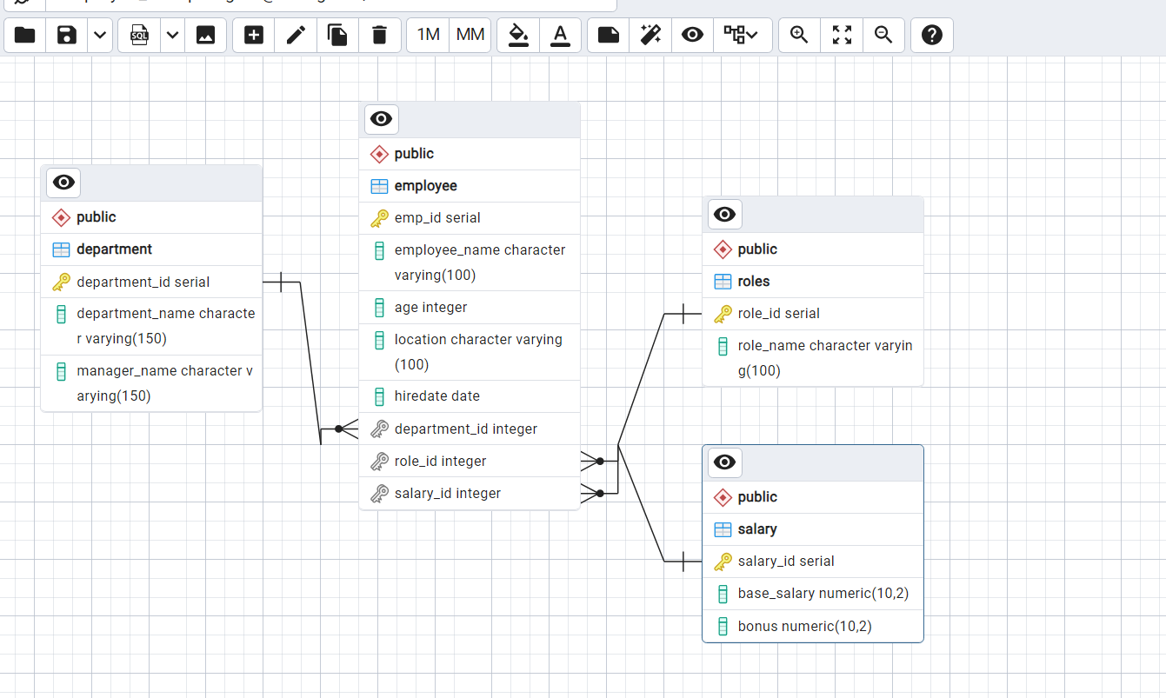Create data base of Employee information where it should the information of employee like in which department they work and what is the role of that employee and also salary info. This data contain almost 5000 employees data and we divide into 4 table for data redundancy. Also all 4 tables contains relationship between them to easily understand the data.

In this ERD model we see the relationship between the four tables. It is like Normalization process where each table contain one primary key and we normalized the data through foreign key we normalized the data.